

Mastering Editors

ASSIGNMENT #3 FOR OSYS1000: UNIX OPERATING SYSTEM



February 3, 2020

JAMIE LU

W0441213

1) How is vi a modal text editor?

- A modal text editor is a text editor that has multiple interaction modes that are optimized for specific types of action and interaction. Each mode in a modal text editor will allow the user to have their objectives realized in a more powerful and effective manner. (Wincent, 2017). Vi is the default editor that comes with the UNIX operating system. Vi is a formidable text editor. It is a modal text editor because the user can edit a text file with more power. It is advanced and has a lot of features to it.

What modes does it have and how do you switch between modes?

* Command Mode
  + This is the mode that vi has when it starts up. This mode is unique because you can’t type in this mode. When you type it’ll result in an unexpected behavior and will not show any display. This is because vi interprets any characters that the user types as commands.
  + One can select, copy, cut and paste text in this mode.
  + To enter command mode from any other mode, press the **esc** key.
* Insert Mode
  + This mode allows the user to insert text in Vi. Once you are in this mode, you can start typing and Vi will allow you to insert the characters that you type rather than interpreting them as commands.
  + To enter insert mode, position the cursor in command mode and press the **i** key once.
  + To leave insert mode, press the **esc** key and you will be brought back to command mode.
* Prompt Mode (sort of a pseudo mode)
  + You can type in additional and more lengthy commands in this mode
  + To enter prompt mode, either “**:**”, ”**/**”, ”**?**”, or ”**!**” are used with the specific command.
  + To exit prompt mode and go back to command mode, you hit **return** or **enter** after typing the command.

2) Log into https://www.lynda.com/ and find the video called Learning vi by David Levine. Download and install the exercise files into the home/user/Documents/Exercise_Files folder that you created on your VM.

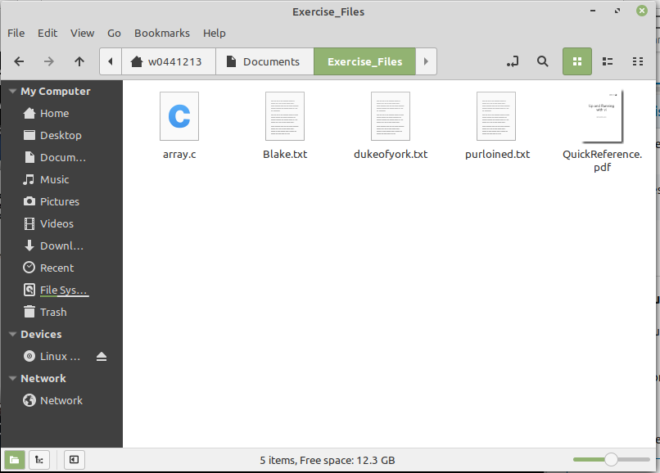

*SCREENSHOT OF THE CONTENTS OF THE EXERCISES_FILES FOLDER INSIDE THE DOCUMENTS FOLDER*

Print off (or have digital access to) the QuickReference.pdf file.

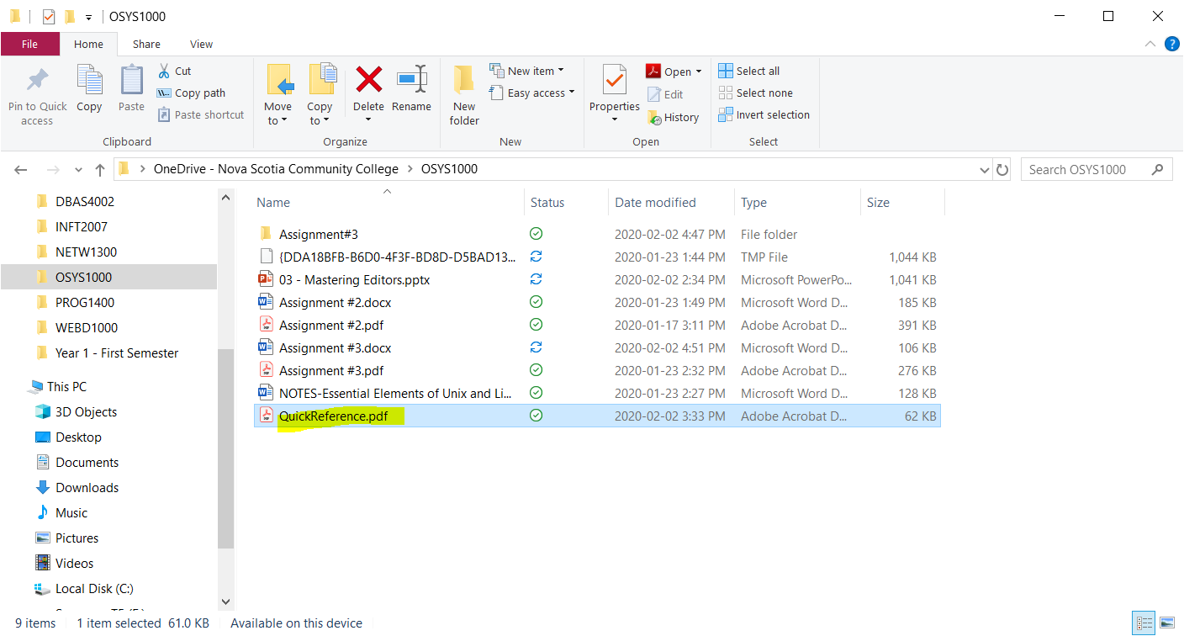

*SCREENSHOT OF DIGITAL ACCESS TO THE QUICKREFERENCE.PDF FILE*

Watch the first 4 sections (1. Exploring vi, 2. Getting Started with vi, 3. Moving Around within a File, 4. Basic Text Editing) and follow along on your VM.

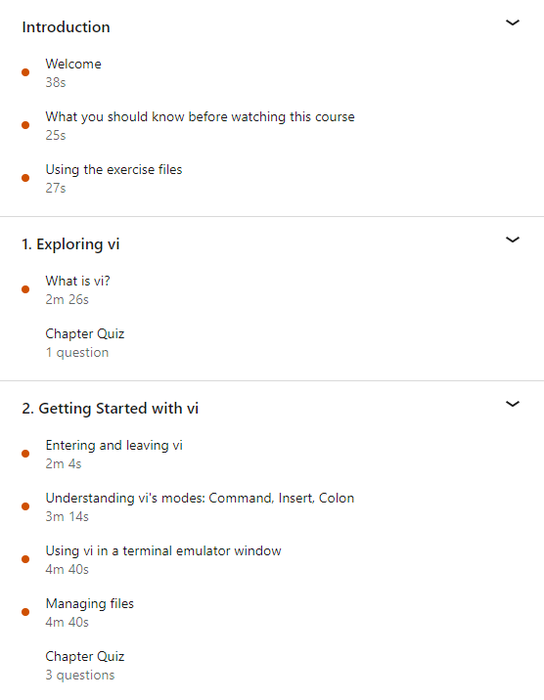

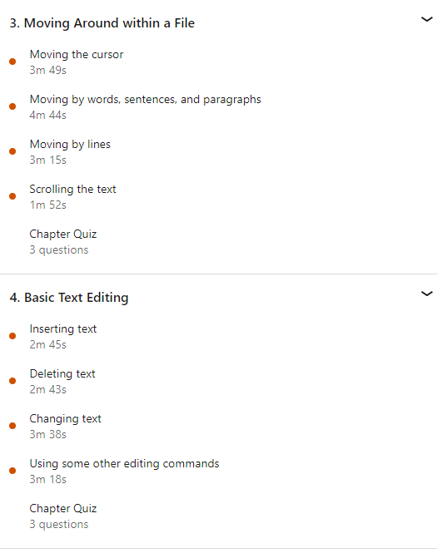

3) Use vi to open the poems.txt file, remove the Shelley poem, and save only the Blake

poem in a file called Blake.txt Call me over to view the contents of this file or print off a

screenshot and attach it to your assignment.

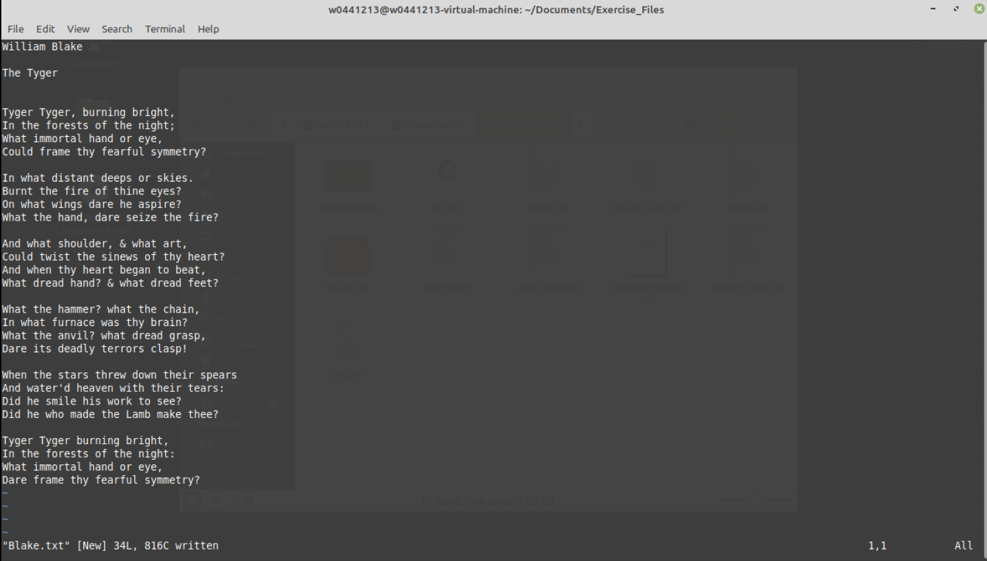

*SCREENSHOT OF SAVING THE NEW BLAKE.TXT FILE*

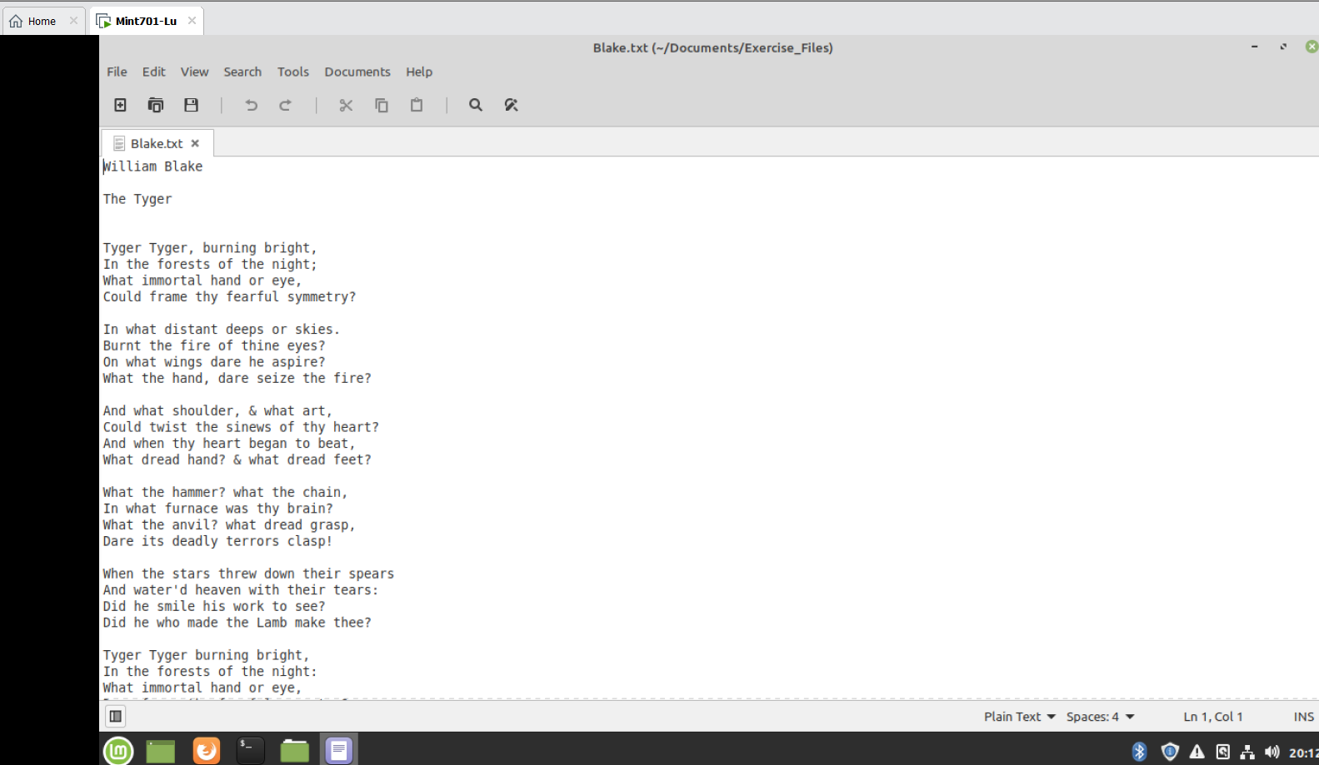

*SCREENSHOT OF THE CONTENT OF THE BLAKE.TXT FILE*

4) Watch the remaining sections (5. Undo, Repeat, Yank, and Put, 6. Search and Replace,

7. Advanced Editing Features, and Conclusion).

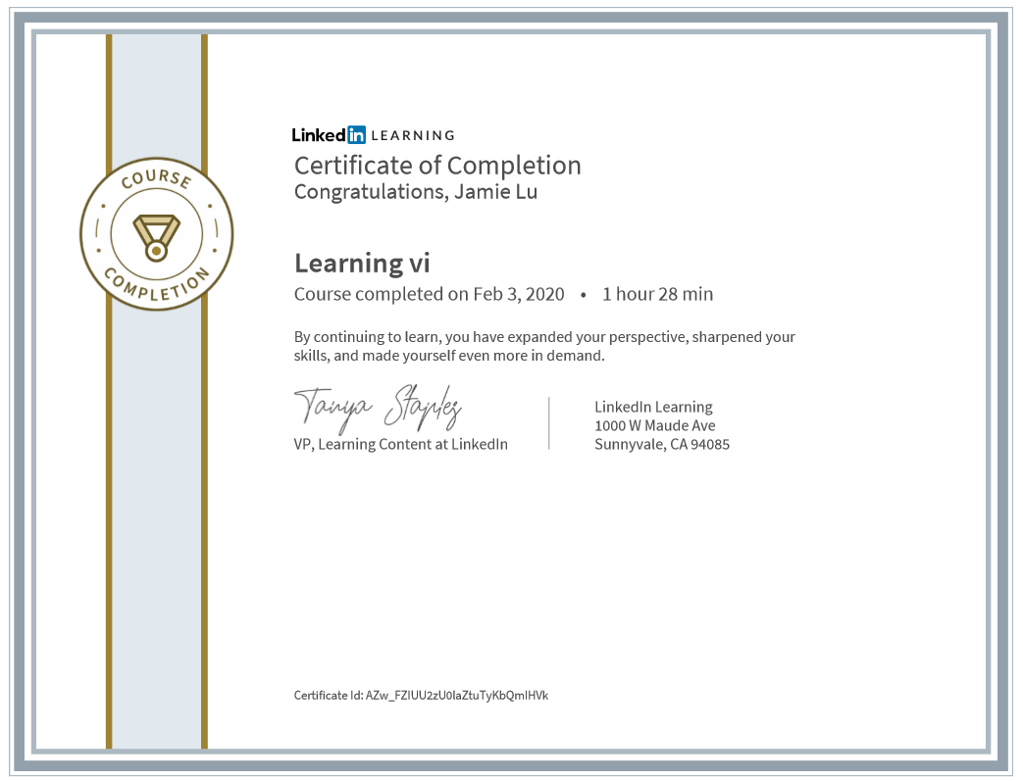

5) Another text editor that is similar to vi is called vim (short for vi improved). Open a terminal

in your VM and install vim and vimtutor.

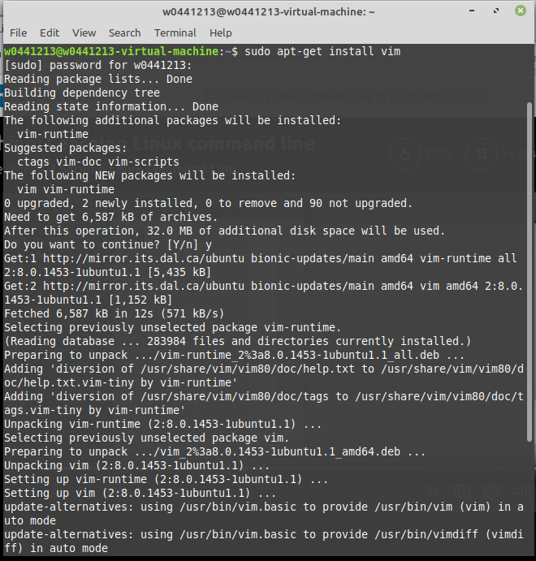 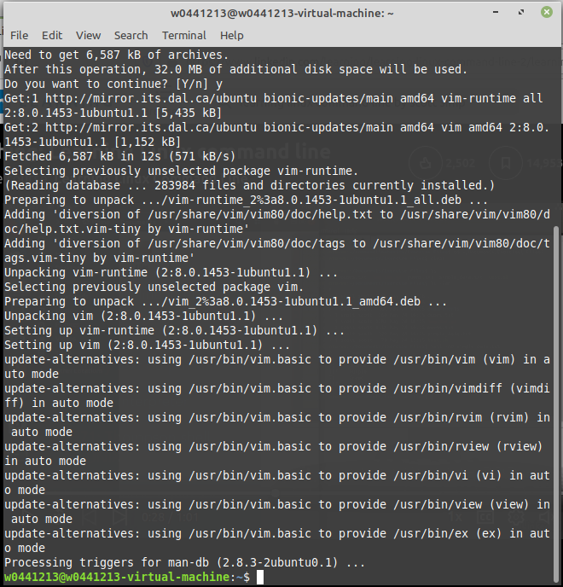

*SCREENSHOTS OF INSTALLING VIM*

Return to Learning Linux Command Line by Scott Simpson, on https://www.lynda.com/

and watch the Edit text with Vim and Edit text with nano sections in 3. Common

Command-Line Tasks and Tools.

Run vimtutor. As you work through the tutorial take screenshots that show you

completed the following sections:

2.1 Deletion Commands

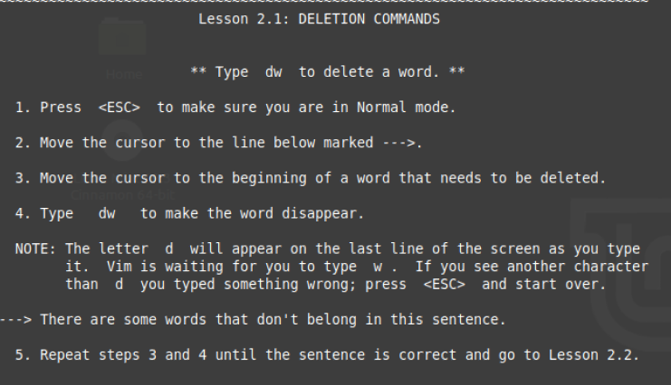

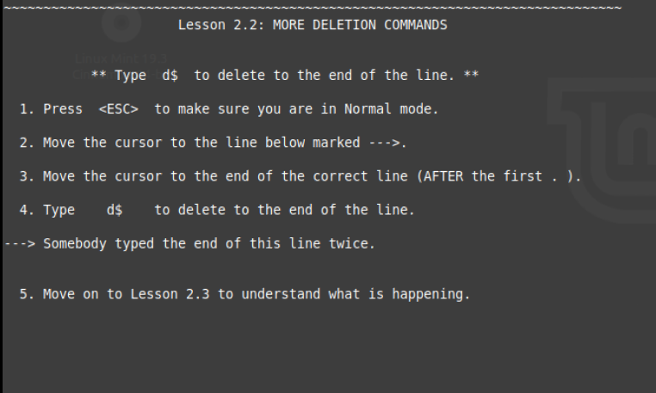

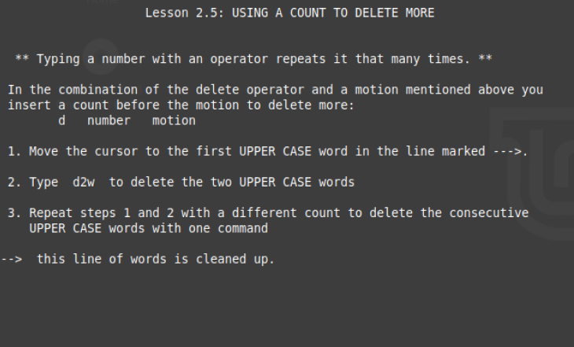

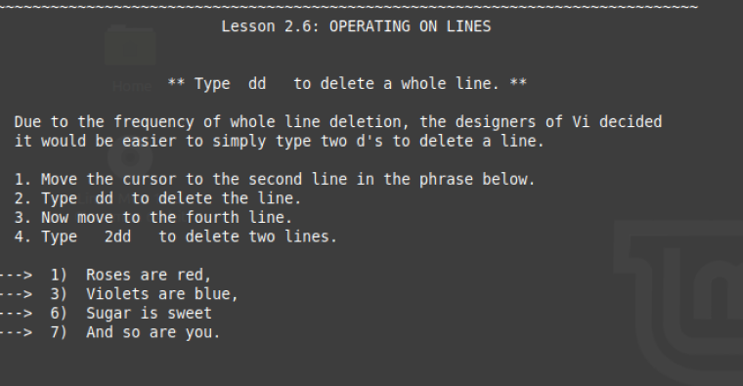

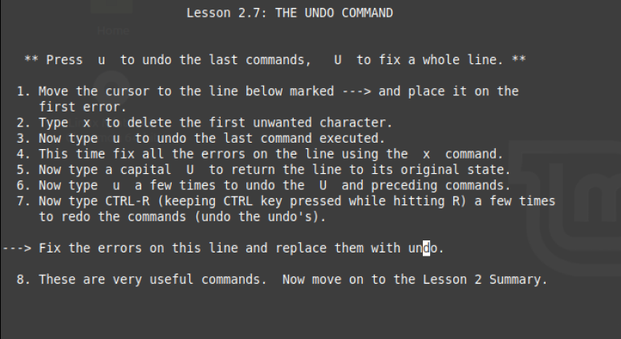

3.2 The Replace Command

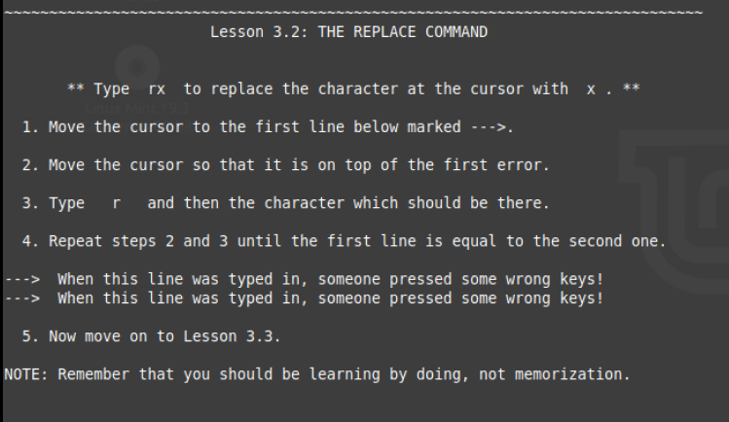

4.4 The Substitute Command

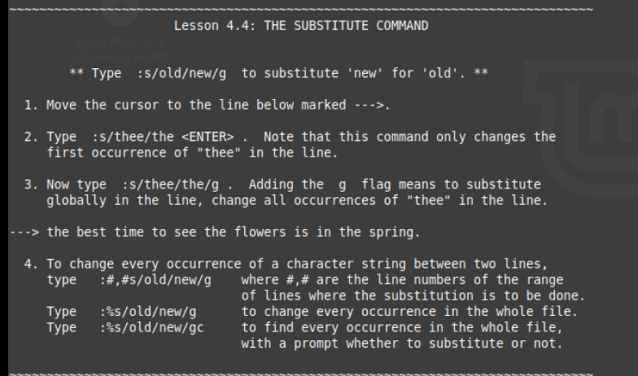

6.4 Copy and Paste Text

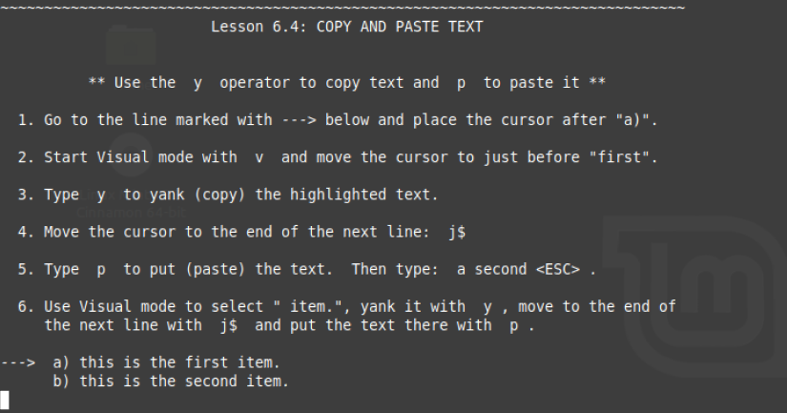

Call me over to view your screenshots or print them off and attach them to your

assignment.

6) Install nano and use it to create a one page reference (cheat sheet) of commands for vi.

Be sure to include:

Switching modes

Inserting text

Navigating a document

Editing a document

Searching and replacing text in a document

Regular expressions

Anything else you think would be useful

Some examples

Call me over to view the cheat sheet open in nano or take a screen shot and attach it to

your assignment.

SCREENSHOTS OF VI CHEAT SHEET MADE WITH NANO:

